INTRODUCE MYSELF

- What’s your…………………………………………. ?

- My ………………………………………… is ………………………………………… .

- What’s your ……………………………………………………….. ?

- My ………………………………………… is ………………………………………… .

- Do you have ……………………………. or …………………………….. ?

- I have ……………………………………………………………………………………………………………… .

- What’s your ………………………………………………………. ?

- I am ………………………………………………. .

- How …………………………………………………………. ?

- I ……………………………………………………….

INTRODUCE MYSELF

- What’s your…………………………………………. ?

- My ………………………………………… is ………………………………………… .

- What’s your ……………………………………………………….. ?

- My ………………………………………… is ………………………………………… .

- Do you have ……………………………. or …………………………….. ?

- I have ……………………………………………………………………………………………………………… .

- What’s your ………………………………………………………. ?

- I am ………………………………………………. .

- How …………………………………………………………. ?

- I ……………………………………………………….

INTRODUCE MYSELF

- What’s your…………………………………………. ?

- My ………………………………………… is ………………………………………… .

- What’s your ……………………………………………………….. ?

- My ………………………………………… is ………………………………………… .

- Do you have ……………………………. or …………………………….. ?

- I have ……………………………………………………………………………………………………………… .

- What’s your ………………………………………………………. ?

- I am ………………………………………………. .

- How …………………………………………………………. ?

- I ……………………………………………………….

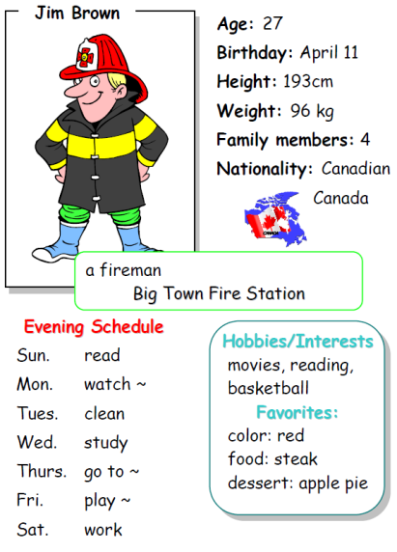- What’s your first name ? (= What **is** your first name?)

- My first name is Jim.

- What’s your family name? (= What **is** your family name?)

- My family name is Brown.

- How old are you?

- I am 27 years old. (= I am 27)

- Do you have brothers or sisters?

- Yes, I do.

- What’s your nationality? (= What **is** your nationality?)

- I am Canadian.

- What’s your first name ? (= What **is** your first name?)

- My first name is Jim.

- What’s your family name? (= What **is** your family name?)

- My family name is Brown.

- How old are you?

- I am 27 years old. (= I am 27)

- Do you have brothers or sisters?

- Yes, I do.

- What’s your nationality? (= What **is** your nationality?)

- I am Canadian.

- What’s your first name ? (= What **is** your first name?)

- My first name is Jim.

- What’s your family name? (= What **is** your family name?)

- My family name is Brown.

- How old are you?

- I am 27 years old. (= I am 27)

- Do you have brothers or sisters?

- Yes, I do.

- What’s your nationality? (= What **is** your nationality?)

- I am Canadian.

- What’s your first name ? (= What **is** your first name?)

- My first name is Jim.

- What’s your family name? (= What **is** your family name?)

- My family name is Brown.

- How old are you?

- I am 27 years old. (= I am 27)

- Do you have brothers or sisters?

- Yes, I do.

- What’s your nationality? (= What **is** your nationality?)

- I am Canadian.

Where do you come from ? What is your nationality ? ANG …..



I come from France.

I live in Paris.

I am French.

I come from Canada.

I live in Toronto.

I am Canadian.



Jen come**s** from France. Jim come**s** from Canada.

**She** live**s** in Paris. **He** live**s** in Toronto.

**She** **is** French. **He** **is** Canadian

Where do you come from ? What is your nationality ? ANG …..



I come from France.

I live in Paris.

I am French.

I come from Canada.

I live in Toronto.

I am Canadian.



Jen come**s** from France. Jim come**s** from Canada.

**She** live**s** in Paris. **He** live**s** in Toronto.

**She** **is** French. **He** **is** Canadian

Where do you come from ? What is your nationality ? ANG …..



I come from France.

I live in Paris.

I am French.

I come from Canada.

I live in Toronto.

I am Canadian.



Jen come**s** from France. Jim come**s** from Canada.

**She** live**s** in Paris. **He** live**s** in Toronto.

**She** **is** French. **He** **is** Canadian

|  |  |  |  |
| --- | --- | --- | --- |
| Name | Country | City | Nationality |
| Marco | Italy |  | Italian |
| Denis |  | Berlin | French |
| Jane |  | Canberra |  |
| Kio |  | Tokyo | Japanese |
| Jerry | Great Britain |  |  |
| Mary | USA | Washington |  |

|  |  |  |  |
| --- | --- | --- | --- |
| Name | Country | City | Nationality |
| Marco | Italy |  | Italian |
| Denis |  | Berlin | French |
| Jane |  | Canberra |  |
| Kio |  | Tokyo | Japanese |
| Jerry | Great Britain |  |  |
| Mary | USA | Washington |  |

|  |  |  |  |
| --- | --- | --- | --- |
| Name | Country | City | Nationality |
| Marco | Italy |  | Italian |
| Denis |  | Berlin | French |
| Jane |  | Canberra |  |
| Kio |  | Tokyo | Japanese |
| Jerry | Great Britain |  |  |
| Mary | USA | Washington |  |